Ram module

(8-bit)

GROUP MEMBERS:

* Yousuf Ahmed siddiqui (k21-4594) <<GROUP LEADER>>
* Muhammad Aalyan (k21-3432)

FEATURES:

* 32-bit random access memory
* On breadboard
* Has a ALU associated with it which will perform simple

(8bit) operations of addition, subtraction, and all comparison operators (equal, greater, lesser)

* Features a enable data output option and

A Memory address register

* Each memory cell has real time visuals representing the bits being stored

MATERIALS USED:

* 6 Breadboards GL-12
* 45 ics
* 50-meter data lines
* 50 leds+ 50 resistors 500ohms
* Has a 6v,4A VC power supply
* 7475 ics (d-latch)

How to use ram?

* We input values at data lines
* And select the memory address where the value has to be stored, one may have to use memory address register to choose the memory address to store value
* We can perform these calculations in our ram module
  + - A+b;
    - A+=10;
    - Int a;
    - Char a;
    - If(a==b);
    - If(a>b);
    - If(a<b);
    - A+256;
    - A++;
    - Float a;
    - -A;
    - And 20 more…
* To transfer values from ram into alu unit we have to choose the memory location to transfer the memory into alu unit through parallel universal data lines
* Values transferred will be accepted first into accumulator a and b
* Later we will perform some calculations with the bits and can allow the value to be stored into memory again

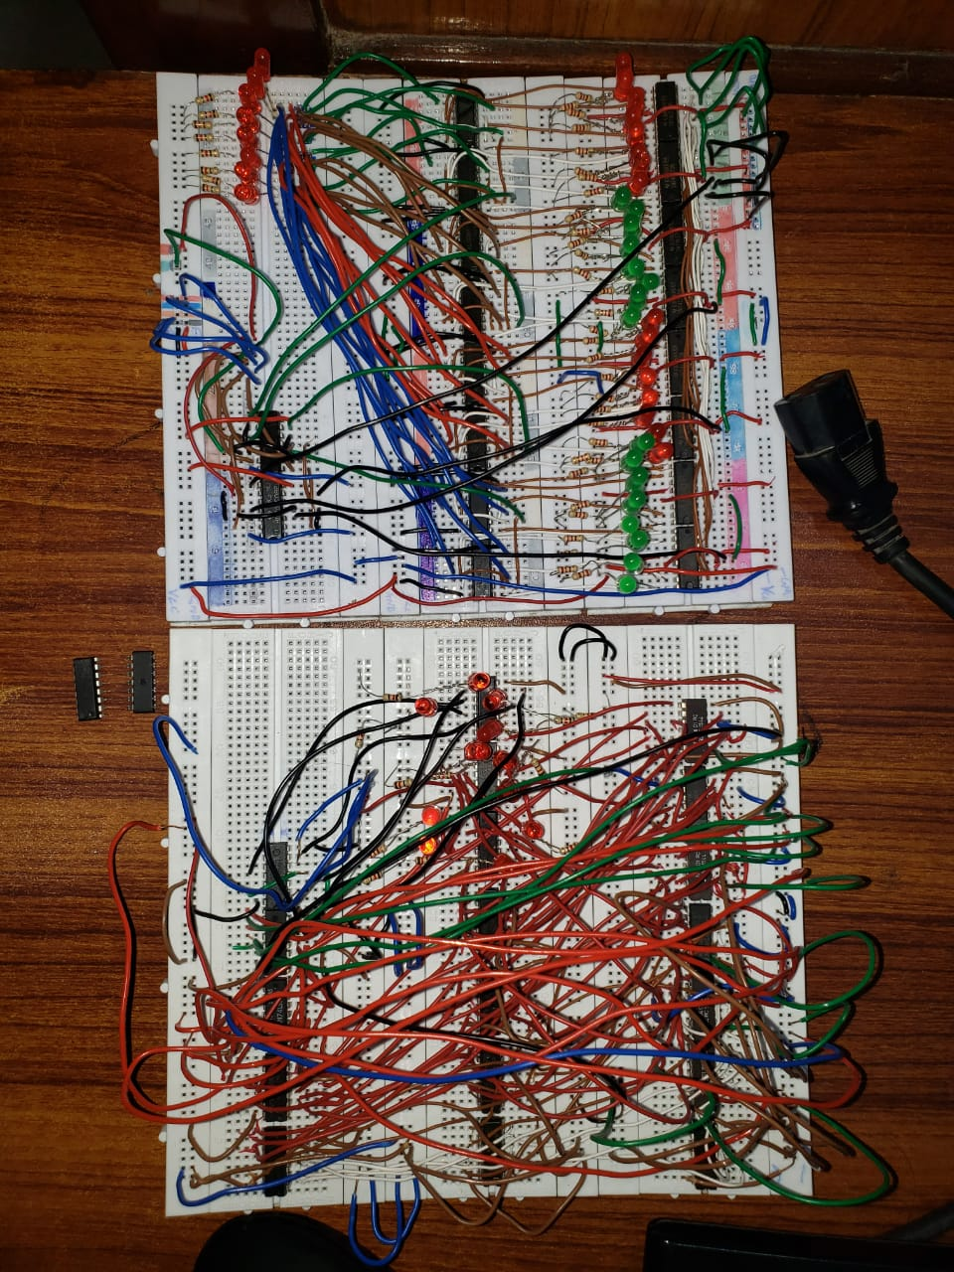our progress pictures…



